OUTPUT:

OUTPUT:

OUTPUT:

OUTPUT:

OUTPUT:

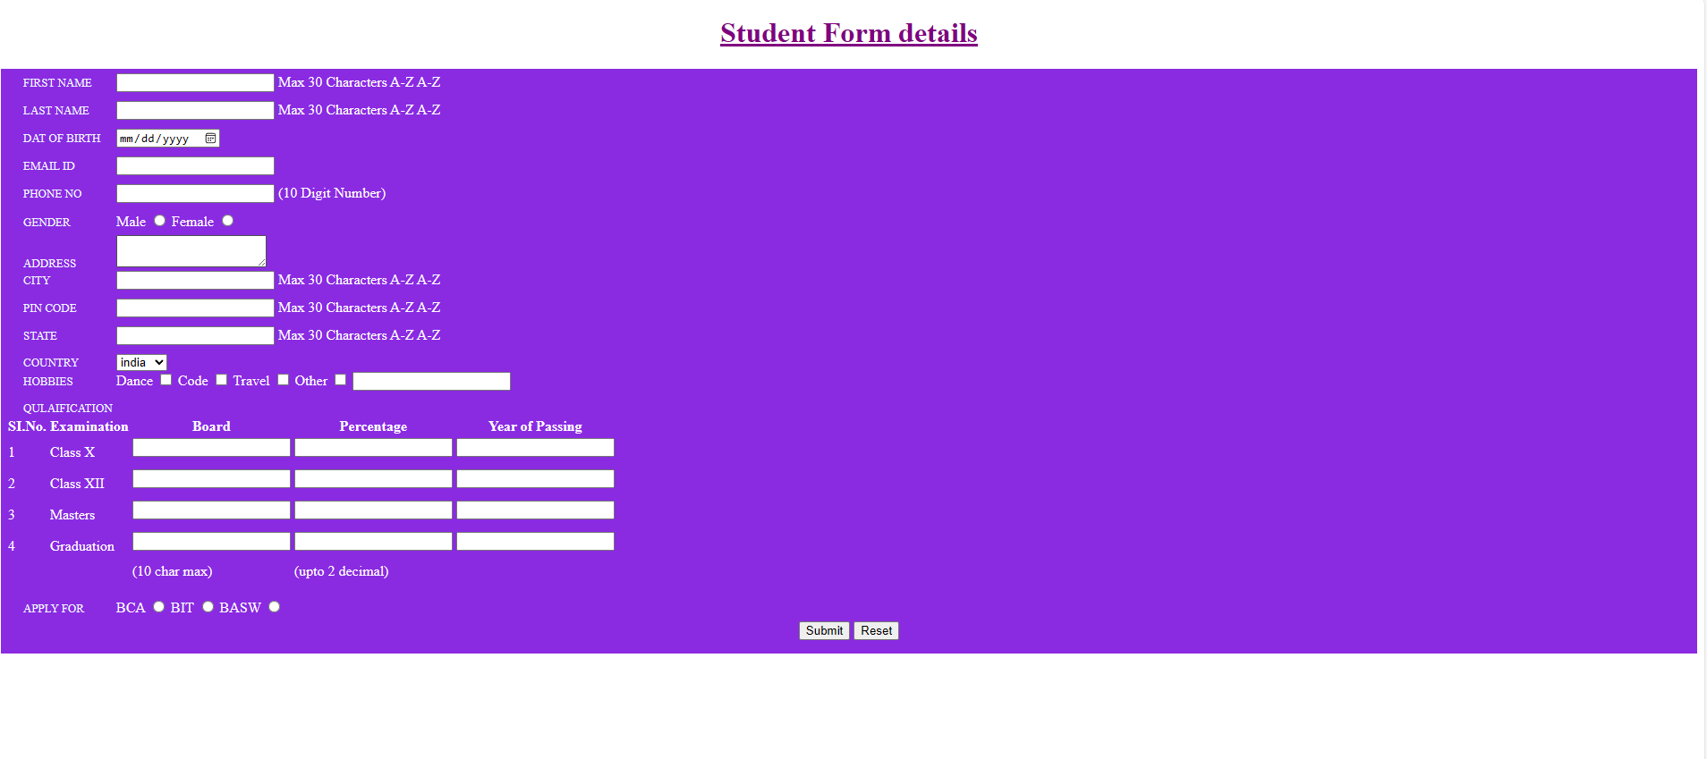

OUTPUT:

OUTPUT: